AI Content Moderation System
INF1103 Team Project Part 1: Engineering Report
Team ID: P10-T4
GitHub Repository: https://github.com/GreyCatCoding/INF1103-P10-T4.git

Name | Student ID | Email
Brian Low De Quan | 2603204 | 2603204@sit.singaporetech.edu.sg
Poh Yi Xiang | 2603205 | 2603205@sit.singaporetech.edu.sg
Sena Nathaniel Luis Villaflor | 2602477 | 2602477@sit.singaporetech.edu.sg
Tan Zane | 2603186 | 2603186@sit.singaporetech.edu.sg
Peh Yang Rui Glenden | 2670042 | 2605764@sit.singaporetech.edu.sg
Yap Yison | 2605764 | 2605764@sit.singaporetech.edu.sg

Date of submission: 14 October 2026

Introduction
Third-party companies may process large volumes of reports from small and mid-sized online platforms. Keyword, regular-expression and blocklist tools can detect explicit prohibited terms but often cannot interpret context. They may miss evolving slang or the difference between endorsing harmful words and quoting them to criticise them. This can create false positives and false negatives, enlarge manual-review queues and contribute to inconsistent decisions and moderator workload.
We propose a terminal-based system that helps human moderators make informed decisions on reported social media content. It analyses each report, then applies predefined rules to recommend a review priority and action. The system works to aid human decision making and will not automatically take drastic actions (such as suspending or banning users).
Data Flow Diagram
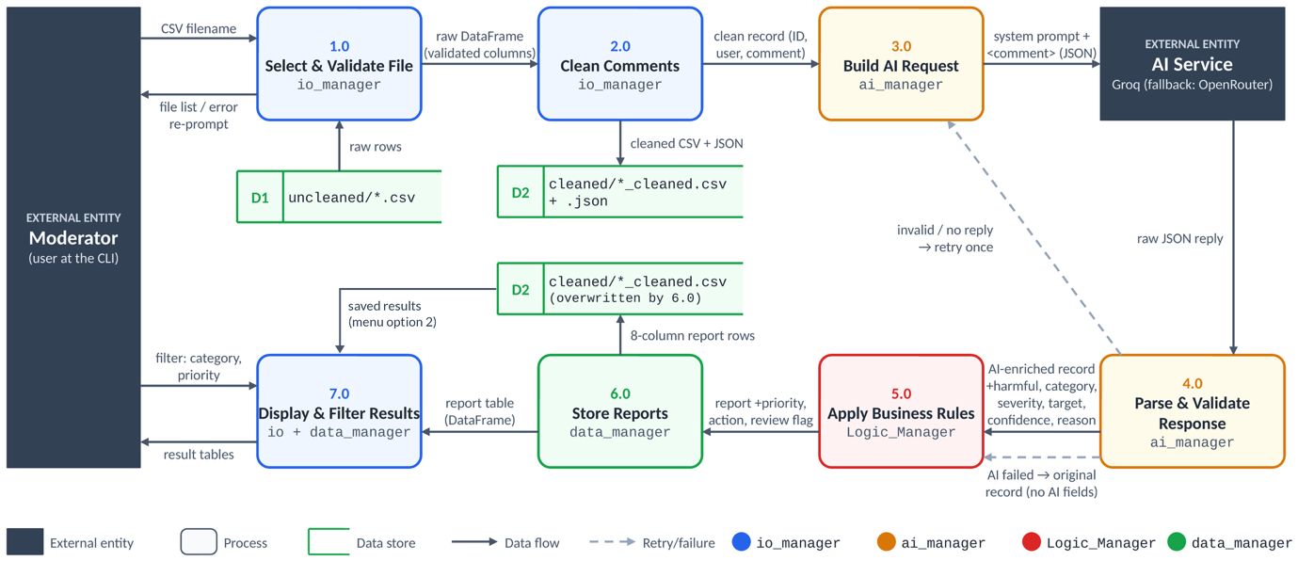
1) Select input file (IO Manager)
The moderator picks a CSV file of comments from the uncleaned folder (D1). The system lists the available files and asks for a filename. If the name does not match any file, the system will not crash but instead show the list again and asks for user input again.
2) Validate and clean comments (IO Manager)
The system first checks that the chosen file is not empty and that it has a comments column and a username column, with exactly these lowercase names. If either check fails, the moderator is asked to choose another file. The comments column is then pre-processed: it is converted to lower case, common slang is expanded (e.g. “imo” becomes “in my opinion”), and links, emails and punctuation are removed. Digits and the symbols $ * @ ! are deliberately kept, so disguised words such as “l0ser” or “sh!t” reach the AI intact. The pre-processed data is then saved to the cleaned folder (D2) as both a CSV and a JSON file. The CSV keeps both the original and processed comments. The JSON keeps only User ID, username and processed_comments. Each record then moves on to the ai_manager, which uses only the processed_comments field when building the request.
3) Build API request payload (AI Manager)
Every record with a non-empty comment will be passed to the ai manager, with records that have empty comments being skipped and later flagged for manual review. The system wraps the processed comment inside <comment> tags and sends it with a predefined system prompt. The prompt defines the harm categories and the severity scale, and requires the model to reply in JSON format only. The request also sets JSON mode and a temperature of 0, to keep replies consistent. The request goes to the main provider, Groq. If the Groq call fails for any reason (a timeout, a connection error, an HTTP error, a missing API key, or an unusable reply), it is retried with OpenRouter as the fallback provider.
4) Parse and validate AI response (AI Manager)
The AI service returns a raw text reply. The system then removes any markdown code fences and parses the text as JSON. The parsed result is then checked against a fixed schema before any field is used. It must be a JSON object with all six expected keys (harmful, category, severity, target, confidence and reason) and each value must have the right type and be in range. The fields must also not contradict each other. If the reply cannot be parsed or fails validation, the request is sent once more. If a valid reply is received, the six AI fields are merged into the original record and passed on to the Logic Manager. If both attempts fail, the error is logged and the original record is passed on without AI fields, so the system continues instead of crashing. The system pauses 40 seconds between records to stay within the AI provider’s rate limit.
5) Apply business rules (Logic Manager)
The Logic Manager first re-checks each record to make sure that the User ID is a non-negative whole number, the username and comment are not empty, and all AI fields are present and valid. It then assigns a moderation priority:
- P1: severity 4, confidence of at least 0.80, and either a high-risk category (hate, violence or self-harm) or a target that is an individual or a group
- P2: severity of at least 3 and confidence of at least 0.70
- P3: any other harmful comment
- P4: comments that are not harmful
A comment is flagged for human review if the AI’s confidence is below 0.70, its severity is 3 or more, or it is P1 or P2. Each priority maps to a recommended action. A plain-English description of the category is also added. Any record that fails the re-check, including records that never received an AI result, is not dropped. It is marked “Manual review required” so a human moderator can look at it instead of crashing the program. Reports are then sorted by a 0 to 100 risk score (severity × confidence × category weight), highest first, with manual-review records at the top.
6) Store reports (Data Manager)
The data manager converts the list of reports into a table with eight columns: User ID, username, comment, category, category description, priority, recommended action and the AI’s reason. Missing values are left blank. The table is saved as a CSV in the cleaned folder, overwriting the cleaned CSV produced in step 2, so the file now holds the moderation results.
7) Display and filter results (IO Manager and Data Manager)
The IO Manager shows each result as a record card, followed by a summary that counts the results by priority and by category. It then offers a filter menu. The moderator can filter by category, by priority, or both, and must enter at least one; leaving both blank shows an error and asks again. The filter itself is carried out by the data manager’s query function. It ignores capitalisation and treats spaces as underscores, so “Self Harm” matches “self_harm”. The matching rows are printed, or “No matching records found” is shown. The moderator can filter again or return to the main menu. Menu option 2 reopens a saved results file without calling the AI: the data manager checks the file exists, is not empty and can be read, then loads it for the same display and filter.
Data Structure and Storage Design
File | Format | Written By | Contents
uncleaned/*.csv | CSV | Provided by the moderator (read by io_manager) | Raw comments: User ID, username, comments, timestamp
cleaned/*_cleaned.csv | CSV | io_manager | Full cleaned dataset: User ID, username, original_comments, processed_comments, timestamp
cleaned/*_cleaned.json | JSON array of objects | io_manager | User ID, username, processed_comments
cleaned/*_cleaned.csv (after moderation) | CSV | data_manager.save_reports (read back by load_cleaned_file, menu option 2) | Overwrites the cleaned CSV with 8 columns: User ID, username, comment, category, category_description, priority, recommended_action, ai_reason
.env | Key-value text | The moderator | AI_PROVIDER and the Groq and OpenRouter API keys
Before AI processing (record from io_manager): User ID 0, username "amy", processed_comments "yo bitch ja rule is more succesful then you ll ever be". The record also keeps original_comments and timestamp.
After AI processing (fields added by ai_manager, example values): harmful = true, category = harassment, severity = 2, target = individual, confidence = 0.85, reason = "Direct personal insult aimed at an individual."
Severity is stored as an integer from 0 (no harmful content) to 4 (most severe), and confidence as a decimal from 0.0 to 1.0 showing how certain the AI is. Unlike a True/False flag, numbers let the Logic Manager compare them against thresholds (such as severity of 3 or more, or confidence below 0.70) to set the priority, the risk score and whether human review is needed.
Exception Handling Matrix
The error handling in this system ensures that a single bad input or failed AI call will not stop the run or silently lose a record.
Exception scenario and possible cause | Detection method | Handling strategy | User outcome
I/O Manager
Invalid Menu Selection. Users enter an option outside the available menu choices or enter text instead of a number. | Validate input against the available menu options. | Display an error message and prompt the user to enter a valid option. | Users can retry without restarting the application.
Invalid File Format. Users select a file with an incorrect structure, such as a missing username or comments column. | Only .csv files are listed; get_input_file() reads the header and needs columns named exactly username and comments. | Reject the file and request a supported format. | Users are informed of the issue and can select another file.
Missing or Empty Data. The selected dataset contains missing comments, usernames or empty records. | Check for null or empty values during data cleaning. | Reject empty files; records with missing values are kept and marked “Manual review required”. | Incomplete records are flagged for human review instead of being dropped.
File Not Found. The typed file name does not match any file in the uncleaned folder. | Checks the typed name against the list of files in the uncleaned folder. | Display an error and allow the user to provide another file name. | Error shown and the file list is displayed again.
Corrupt or Unreadable File. A non-text or wrongly encoded file is saved with a .csv extension. | pd.read_csv raises a parsing or decoding error while the file is checked. | Catch the error, display a message and ask for another file. | No crash; users can select another file.
AI Manager
Empty or missing comment. Blank row, or cleaning removed all the text | analyse_record() checks for non-empty text first | Log the User ID and skip the API call | No wasted API call. Sent to manual review
Missing API key or unknown provider. Key not in .env, or a typo e.g. AI_PROVIDER=grok | get_provider_config() checks the chosen provider's key before each request is sent | Log the variable to fix, then fall back to OpenRouter | Still works if the other provider is set up
Connection failure, timeout or HTTP error. Network down, no reply in 60s, 429 rate limit, 401 bad key, 5xx | call_api() catches RequestException from timeout=60 and raise_for_status() | Log, fall back from Groq to OpenRouter (which can also switch to its two backup models), then retry once | Gets a verdict with a worst case 4 minute delay
Unexpected API response. Body not JSON, missing choices / content, or the reply is not text | call_api() catches ValueError, KeyError, IndexError, TypeError, AttributeError and checks for a string | Log, fall back to OpenRouter, then retry once | Usually still gets a verdict
Malformed JSON in the reply. Model wraps the JSON in markdown, cuts it off, or adds text | parse_response() catches JSONDecodeError and TypeError | Strip a markdown fence and parse again. If still invalid, retry once | Wrapped replies are recovered without a retry
Reply fails schema check. Reply is a list or number instead of an object, a field is missing, wrong type or out of range, or fields contradict each other | validate_response() checks every field, including True / False passed as a number | Reject the reply, log the failed check, then retry once | Bad data never reaches the Logic Manager
Logic Manager
Missing AI Output Fields. AI Manager fails to provide required fields such as category. | validate_data() checks for missing dictionary keys. | Raise ValueError; process_reports() catches it and marks the record for manual review. | Record flagged for human review instead of automatic moderation.
Unknown Content Category. AI returns a category not defined in Categories. | Category validation and get_category_description(). | Raise ValueError and send records for manual review. | Unsupported categories are not assigned an arbitrary moderation action.
Invalid Data Type. AI Manager returns a string instead of an integer for “severity” or an invalid type for “confidence”. | validate_data() checks data types using isinstance() and type(). | Reject invalid data using ValueError and recommend manual review. | Prevents incorrect moderation decisions based on invalid data.
Data Manager
Missing, empty or corrupt saved file (load_cleaned_file). Typed name not in the cleaned folder, or the file is 0 bytes, blank or not text. | validate_csv_structure() checks it exists and is not 0 bytes; pd.read_csv raises EmptyDataError or a decoding error. | Raise FileNotFoundError or ValueError; io_manager shows it and asks again. | No crash; the moderator picks another file.
Output file locked (save_reports). cleaned/*_cleaned.csv is open in Excel. | except PermissionError around df.to_csv(). | Log and re-raise; main_menu() catches it and shows a message. | No crash; the moderator closes the file and runs option 1 again.
No matching records (query). No row matches the filter, or the saved file has no category or priority column (moderation never finished). | query() checks both columns exist and lowercases the input (spaces in a category become underscores); io_manager checks results.empty. | Return an empty table instead of raising an error. "SELF HARM" still matches self_harm. | The user sees "No matching records found."
Empty report list (to_dataframe). Every record failed, or the input file had no rows | pd.DataFrame([]) has no rows | reindex still builds the eight display columns | An empty table is displayed. query returns "No matching records found."
Missing report columns (to_dataframe). The logic manager returned error dicts, or a record without a category or priority | DataFrame.reindex(columns=DISPLAY_COLUMNS) | Missing columns are created and fillna("") blanks the empty values | The program doesn't crash. Those rows show blank category and priority and can't be matched by the filter.
Wrong file extension (save_reports). The caller passes data or data.txt | output_path.suffix != ".csv" | The suffix is replaced with .csv | The file is saved as .csv.
Non-string or blank values (query). Blank values from failed AI records | .astype(str) before .str.lower() | Converts everything to a string before comparing | No crash. Those rows simply don't match.

